Getting started with Palantir
The Palantir platform is designed to help you use data to solve real-world problems. The Palantir platform is used by:
- All types of organizations: From early-stage startups, to multinational companies, to governments around the world.
- All types of users: From IT administrators, software engineers, and data scientists, to nurses, technicians, and operators.

Introductory concepts
As you get started in the Palantir platform, it can be helpful to think about data in the platform living in two places: the data layer and the object layer.

Data Layer
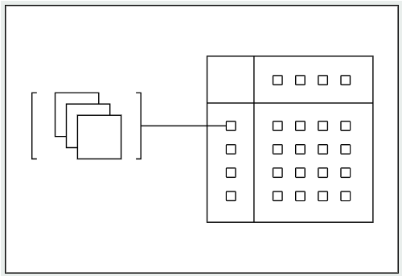
In the data layer, data is stored inside datasets, which typically represent tabular data like you might find in a spreadsheet, but support data at any scale. Datasets usually come from organizational data sources that are synced into the platform, but you can also create your own datasets by uploading approved or notional data.
Every dataset in the Palantir platform maintains a record of how it was produced, so that the origins of data are always preserved and accessible. This concept is known as data lineage.
- Palantir keeps track of which input datasets were used to produce which output datasets. This allows you to always know where a piece of data came from, and understand how data is used.
- Palantir tracks the logic that was applied to produce each output dataset. For example, an input dataset might be filtered to produce a smaller output dataset; that filtering logic is preserved and visible in the platform. There are many ways to write logic in the platform, ranging from code repositories to point-and-click tools.
You can interact with data using one of Palantir's many applications. When you use applications, anything you produce, whether it is a dataset, code, or analysis, is stored in the platform as a resource. Resources are organized into Projects, which serve as permission boundaries for grouping and organizing related work.

Object Layer (Ontology)
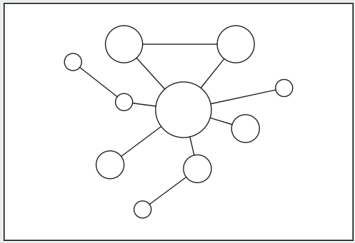
In the object layer, or Ontology, data is stored in objects and links. Objects represent real-world concepts like an airplane, vehicle, or customer, while links represent the relationships between objects. The object layer takes the data stored in tabular datasets—rows and columns of data—and converts it into a series of concepts that anyone in the organization can understand.
In addition to helping make data more understandable, converting data from datasets into objects and links unlocks a broad set of tools for interacting with objects. You can define actions that describe how objects can be changed by people in your organization. This enables you to build applications that access data from objects and capture user decisions back into the system.
The definitions of objects, links, and actions together make up what is called the Ontology, a digital representation of your organization. Developing and using the Ontology to translate data into operational outcomes is a key part of getting value out of the Palantir platform.

Orientation and navigation
You can think of the Palantir platform as an operating system for the data in your organization.

The Sidebar
The sidebar is your constant companion in the platform and the starting point for navigation. Open and collapse the sidebar with the icon in the upper right or with the keyboard shortcut Cmd+O (macOS) or Ctrl+O (Windows).
The sidebar has five primary sections that allow you to navigate to different features and tools within the platform:
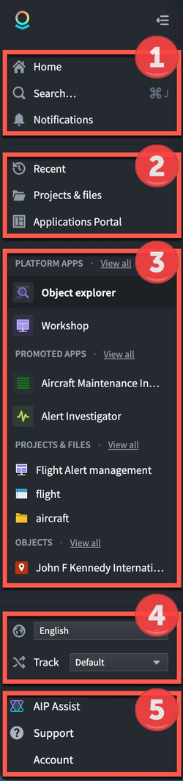 | ① Home: Return to your organization's landing page  ① Search: Open the Quicksearch dialog  ① Notifications: View platform and app notifications  ② Recent: Quickly navigate to recently accessed resources  ② Projects & files: Jump to the Projects landing page  ② Applications Portal: Find and access all Apps in the platform  ③ Favorites: Organize and access your favorite apps, resources, and objects  ④ Language: Change the language of the interface  ⑤ AIP Assist: LLM-powered assistant for getting help  ⑤ Support: Access Palantir documentation, training resources, and help  ⑤ Account: Find account details and review permissions and groups  ⑤ Other Workspaces: Access custom Workspaces and the Control Panel (availability depends on permissions)

AIP Assist
AIP Assist can answer questions about the platform in multiple languages and can provide guidance about how to use the platform, including tutorials.
You can access AIP Assist from the lower-right corner of the sidebar or by using the keyboard shortcut Cmd+U (macOS) or Ctrl+U (Windows).
AIP Assist is "context-aware" in that it can detect which application you are currently working in, but AIP Assist does not have access to any of the data you are working with.

Home
New Palantir enrollments come with an default home page that helps users orient themselves and learn about the platform. Administrators or builders can also create custom landing pages for various user groups on the platform. Some enrollments may use a completely customized home page, while others may use standard components to provide access to frequently-used parts of the platform.
While most home pages focus on navigation, you may also find announcements about the platform, starting points for common workflows within your organization, or links to custom documentation on the landing page.
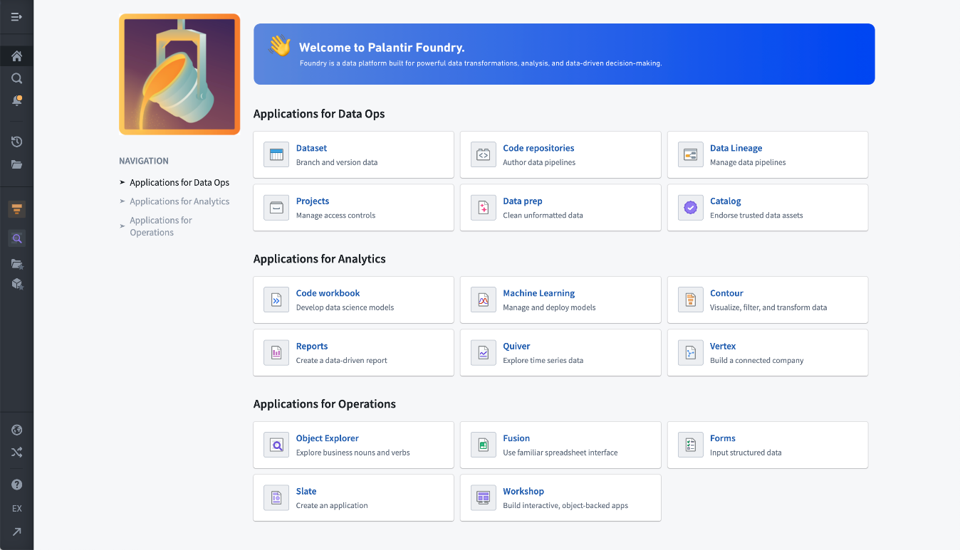

Search
Search, also known as Quicksearch, is a tool for navigation and discovery of elements in the platform. Search is made of two parts:
- Jump-to mode: Provides a short list of personalized results to directly navigate users to the main types of available content: platform applications, custom applications, objects, datasets, and other resources.
- Full results mode: Designed to help users find content and discover what exists in the platform. Users can perform searches of platform apps, objects, datasets, and other files with advanced filters, rich metadata, and a ranking algorithm to highlight the most relevant results.
To open Quicksearch, select Search... in the navigation sidebar, or use ⌘ + J (macOS) or Ctrl+J (Windows).

Notifications
The Notifications panel collects notices from across the platform, ordered from newest to oldest. Most notifications include links to navigate directly to the relevant resources. Some, such as access requests, can be responded to inline without needing to navigate to another page.
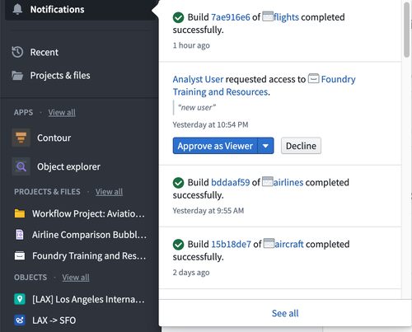
By default, notifications are delivered both within the platform in the Notifications panel and by email. Under the See all link, notifications are grouped by type for easier navigation. The notification Settings give you granular control over global and per-notification-type delivery preferences. If notifications are unread, the bell icon will have a small, yellow badge. If a notification occurs while you’re using the platform, a small pop-up in the lower left corner will briefly show the message.

Recent
The Recent panel simply lists the last 20 resources you’ve opened or interacted with. Between Favorites and Recent, it’s possible to quickly navigate between primary resources in use for any project without needing to return to Search or browse through the Project folder structure.
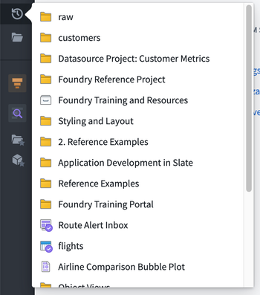

Projects & files
Projects & files links to the landing page for the Project folder structure, where you can access top-level Projects and the Data Catalog, Your files, and Shared with you shortcuts. You will learn more about Projects in the next step of this guide.

Applications Portal
Applications Portal is a tool for finding and accessing all apps in the platform, including both platform apps and custom promoted applications.
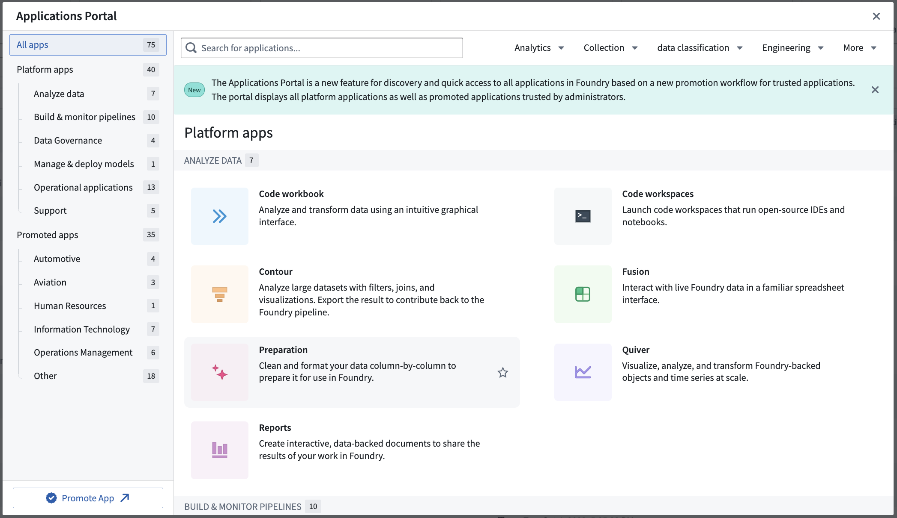

Favorites
The Favorites section of the sidebar keeps links to specific apps, resources, and individual objects for quick navigation. Use Ctrl+Click on Windows or Cmd+Click on macOS to open a favorited resource in a new browser tab.

Favorited Apps
When you first use the platform, your Favorites section is empty and only Apps will show in the sidebar. Choose View All to see all the different applications in the platform, or click the favorited apps text to pop up the Manage your favorites view.
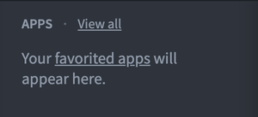 | 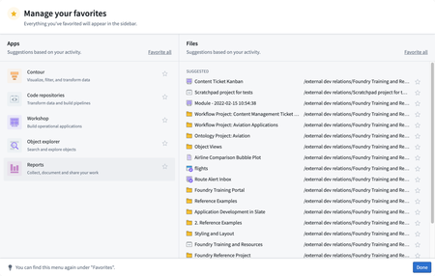
In this view, you will see suggested applications and resources based on your recent usage.

Promoted Apps
You can add useful promoted apps from Applications Portal to the sidebar by selecting the star icon on the Portal (see left). Once on the sidebar, promoted apps will appear under a dedicated section for quick access (see right).
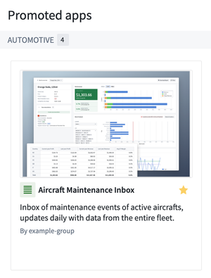 | 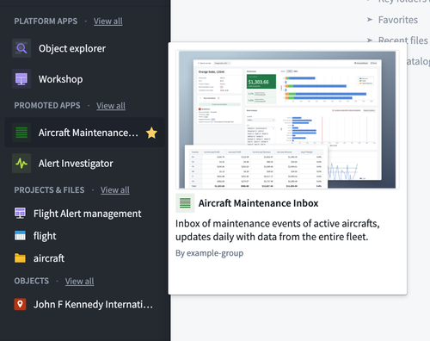

Favorite Resources
You can add and remove favorites with the star icon while navigating the folder structure or from within an open resource.
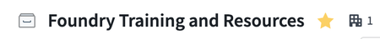
Think of favorites as shortcuts that you can add and remove to keep frequently used resources close at hand.

Favorite Objects
Object Explorer is an application you can use to explore objects and links in the platform. When you navigate to an individual object view, you can select the star next to its title to save it as a favorite. This will add the object to your sidebar.


Help & support
Palantir has a wide range of capabilities, features, and components available for your use cases and workflows. To help you understand how the platform can best serve your needs, the Help & support panel is a starting point for learning more and getting answers to your questions.

Support
The Palantir Customer Success Services team ↗ offers support, training, and consultation services to help you and your organization get the most out of the platform. If included in your agreement, you can contact the team with questions using the Report issue option to create a support ticket in the Issues application.

Account
Click your name in the Account panel to bring up your account overview. Here, you can view recent contributions as well as ones you’ve created that are popular with other users. Click on the Edit Profile button to view your User Settings.

Settings
You can customize your profile with a profile image and additional information to be stored in the platform for viewing by users in your organization. This information will appear when other users hover over your name in Projects and resources. Adding distinguishing information is helpful for operational workflows that rely on assigning work or sharing resources, especially in cases where you share the same name with another coworker.
Within User Settings in the Account tab, you can find your User ID and permission Groups. You may be asked for this information if you have a question about permissions or data visibility.
The Notifications tab is a control center for changing notification delivery settings.

Other workspaces
The main platform workspace is defined by the Workspace sidebar that we have been exploring. You can access other workspaces by selecting Open other workspaces.

Control Panel
Administrators can access the Control Panel workspace for managing an enrollment.

Carbon Workspaces
Application builders can use Carbon to create curated, custom workspaces for their end users. A wide range of applications can be combined together to provide a tailored experience.

